Lecture 3
CO1: Apply the knowledge about the concepts of probability and statistics for the computer applications.
CO3: Apply the knowledge about basic ideas of statistics including measures of central tendency, correlation and regression.

Measures of central tendency
Median
“When the observation are arranged in ascending or descending order, then a value, that divides a distribution into equal parts, is called median”
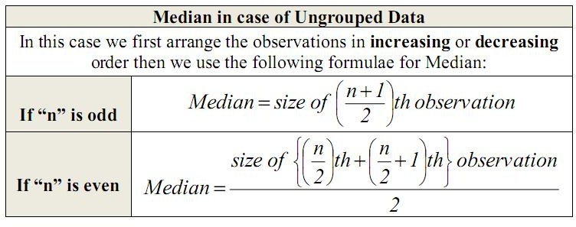

Numerical example of median for both grouped and ungrouped data:
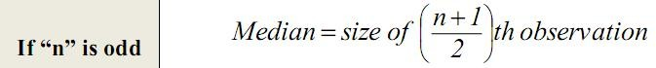

- In an office there are 5 employees: a supervisor and 4 workers. The workers draw a salary of 5000Rs, 6500Rs, 7500Rs and 8000Rs per month while the supervisor gets 20000Rs per month.
In this case mean (salary) =
$\frac{5000+ 6500 + 7500 + 8000 + 20000}{5}$ Rs = 47000Rs = 9400Rs
Note that 4 out of 5 employees have their salaries much less than 9400Rs. The mean salary 9400Rs does not given even an approximate estimate of any one of their salaries.
This is a weakness of the mean. It is affected by the extreme values of the observations in the data.
This weakness of mean drives us to look for another average which is unaffected by a few extreme values. Median is one such a measure of central tendency.
Median is a measure of central tendency which gives the value of the middlemost observation in the data when the data is arranged in ascending (or descending) order.

Median of Raw Data
Median of raw data is calculated as follows:
(i) Arrange the (numerical) data in an ascending (or descending) order
(ii) When the number of observations (n) is odd, the median is the value of $\left(\frac{n+1}{2}\right)th$ observation.
(iii) When the number of observations (n) is even, the median is the mean of the $\left(\frac{n}{2}\right)th and \left(\frac{n+1}{2}\right)th$ observations.
Let us illustrate this with the help of some examples.
Example 1:
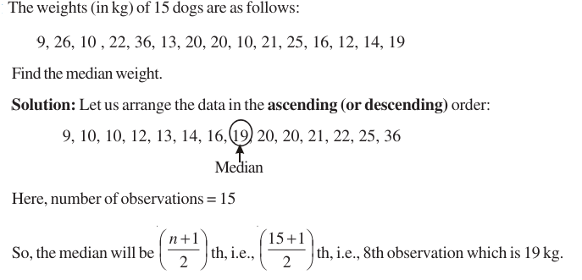
Example 2:
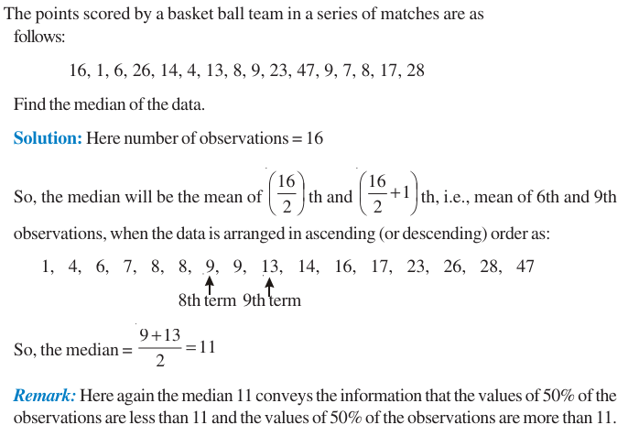

Median of Ungrouped Data:
We illustrate calculation of the median of ungrouped data through examples. Example 3: Find the median of the following data, which gives the marks, out of 15, obtained by 35 students in a mathematics test.
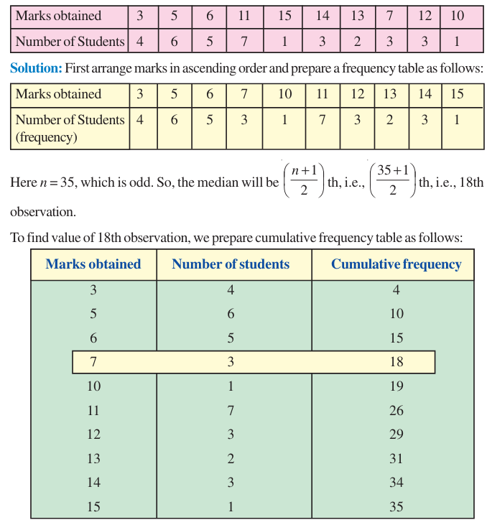
From the table above, we see that 18th observation is 7
So, Median = 7

Example 4: Find the median of the following data:
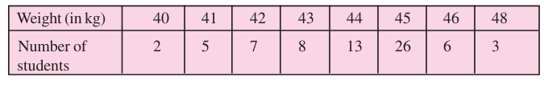

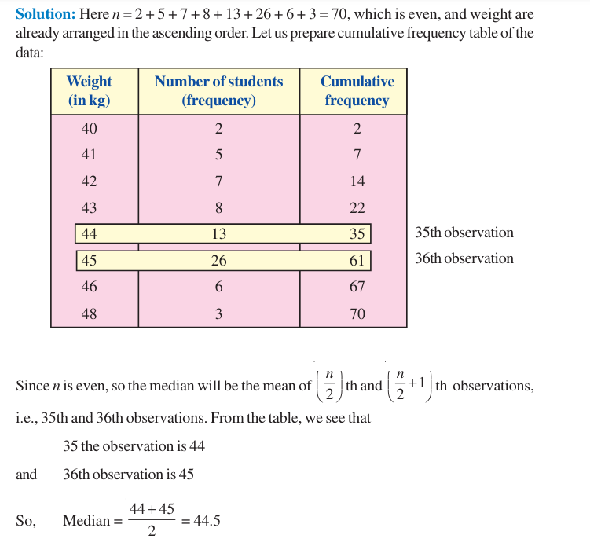

Practice Questions
- Following are the goals scored by a team in a series of 11 matches
1, 0, 3, 2, 4, 5, 2, 4, 4, 2, 5
Determine the median score.
- In a diagnostic test in mathematics given to 12 students, the following marks (out of 100) are recorded 46, 52, 48, 39, 41, 62, 55, 53, 96, 39, 45, 99
Calculate the median for this data.

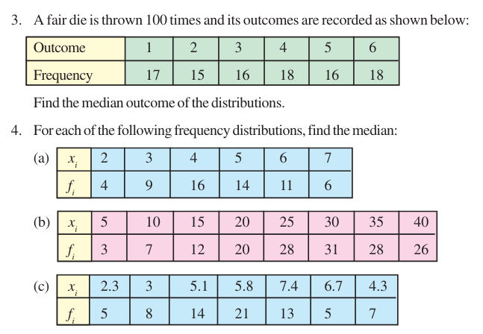

Advantages & Disadvantages of Arithmetic Meadian
Advantages
- Median is not difficult to understand, although it is not so popular as the arithmetic mean.
- It is easy to calculate. Even when all the observations are not known, median can be calculated, provided the general location of all observations and values near the middle are available. Median can also be calculated without difficulty from grouped frequency distributions with classes of unequal width or with open-end classes.
- Median is applicable to qualitative data in psychological and social studies, where numerical measurements may not be available, but it is possible to rank the objects in some order.
Disadvantages
- For the calculation of median, the data must be arranged.
- Unlike A.M. Or G.M. it cannot be treated algebraically. Given the medians of several groups of observations, median of the composite group cannot be determined.
- If is desired to give greater importance to large or small values, median is unsuitable.
- The calculation oof median from a grouped frequency distribution is based on simple interpolation, which assumes that the observations in the median class are uniformly distributed. But in reality, this may not be true.
- Median is affected more by sampling fluctuations than the arithmetic mean, and is therefore, less reliable.

TEXT BOOKS
- T1 = H. K Dass, Higher Engineering Mathematics, S. Chand Publishers,3rd revised edition.2014.
- T2 = B.S. Grewal, Higher Engineering Mathematics, Khanna Publishers,42th ed.2013, New Delhi.
- T3= N. P. Bali and Manish Goyal, A textbook of engineering Mathematics, Laxmi Publications, Reprint 2008.

REFERENCE BOOKS
- R1=R. K. Jain and S. R. K. Lyenger, Advanced Engineering Mathematics ,3rd Edition Narosa Publishing House ,2004,New Delhi.
- R2 =B. V. Ramana Advanced Engineering Mathematics, McGrawHill, July2006, New Delhi.
- S.P.Gupta,StatisticalMethods,S.Chand&Sons,2017,NewDelhi,ISBN9789351610281Insiders’Guide

Video Lecture :
https://www.youtube.com/watch?v=zC6e47l0tV4

